### Sign To Speech Conversion Module

### (For Beginners)

**Problem Statement**

* Develop a real-time sign language recognition and interpretation system using cameras and computers to bridge communication gaps and enhance inclusivity across diverse environments and to make learning sign language easier and more accessible for everyone.
* Accurately detect hand landmarks as the starting point. Train robust deep learning models capable of decoding sign language gestures and overcome technical challenges throughout development, ensuring real-time translation and diverse dataset training.
* Despite technical challenges, remained dedicated to overcoming barriers and refining the system. Stubborn dedication to achieving powerful overall performance and accuracy. Commitment to making communication more inclusive and accessible for everyone.
* Development of a system offering real-time translation capabilities. Training sign language prediction models on diverse datasets to recognize a wide range of sign language variations. Providing immediate feedback and guidance to individuals learning sign language independently or in educational settings.

**OBJECTIVE**

The primary objective of this project is to develop a Real-time Sign Language Detection and Translation System using computer vision and machine learning techniques. Specifically, the project aims to achieve the following objectives:

1. Hand Gesture Detection: Implementing advanced algorithms to accurately detect and track hand gestures in real-time video streams, leveraging the capabilities of OpenCV's Hand Tracking Module.
2. Sign Language Recognition: Train and deploy a deep learning model, preferably based on Convolutional Neural Networks (CNNs), to classify detected hand gestures into predefined sign language symbols with high accuracy.
3. Real-time Translation: Integrating text-to-speech synthesis capabilities to translate recognized sign language symbols into spoken words in real-time, enabling instantaneous communication between individuals using different modes of communication.
4. Customization and Adaptability: Provide options for customization, allowing users to train custom models to recognize additional sign language symbols or adapt the system to different languages and dialects to suit diverse communication scenarios.
5. Testing and Evaluation: Conducting rigorous testing and evaluation to assess the system's performance, including its accuracy in hand gesture detection, sign language recognition, and real-time translation, ensuring reliability and effectiveness in practical applications.
6. Education and Accessibility: Explore the potential applications of the system in educational settings to support the teaching and learning of sign language, as well as it's broader impact on promoting accessibility and inclusion in various environments.

By achieving these goals, the research hopes to provide a novel approach that will enable people with hearing loss to interact with others in an efficient manner.

**INTRODUCTION**

In today's incredibly diverse world, super effective communication is absolutely crucial for fostering major inclusivity and really understanding among individuals from so many different backgrounds. However, for individuals with hearing impairments, that traditional verbal communication possibly may not always be totally sufficient. To bridge this pretty big gap, some super cool innovative technologies like sign language recognition and translation systems are actually emerging as these powerful tools for definitely facilitating communication and super enhancing accessibility.

This project specifically presents a real-time Sign Language Detection and Translation System using computer vision and also machine learning techniques. Definitely leveraging the really great capabilities of OpenCV, a pretty popular computer vision library, and TensorFlow, a leading machine learning framework, this system essentially detects hand gestures in real-time video streams, interprets them as kind of sign language symbols, and translates them into spoken words using text-to-speech synthesis.

**Key features:**

By using a pre-trained deep learning model, the system classifies hand gestures captured in the video feed into predefined sign language symbols. This classification is based on a Convolutional Neural Network (CNN) architecture which trained on a dataset of sign language images.

* **Real-time Translation**: Once recognizing a sign language gesture, the system translates it into spoken words through text-to-speech synthesis. This allows for real-time communication between individuals proficient in sign language and those who rely on spoken language.
* **Sign language recognition:** Using a pre-trained deep learning, the system magically classifies the hand captured in the video into predefined sign language symbols. This spellbinding classification is based on a Convolutional Neural Network (CNN) architecture trained a dataset of sign language images with mystical powers.
* **Education:** The system can be used as an educational tool to teach in individuals interested in learning sign language or to provide assistance to students with hearing impairments in a classroom setting with difficulties.
* **Accessibility:** By providing real-time translation of sign language into spoken words, the system promotes accessibility in various environments and places, including public events, customer service interactions, and online communication platforms that are accessible.
* **Communication Aid**: Individuals who are proficient in sign language may use the system to communicate with others who may not understand sign language, breaking down communication barriers, as well as fostering inclusivity and inclusiveness.
* **Customization**: The system allows for easy customization, enabling users to train their own models with additional sign language symbols or adapt the system to different languages and dialects.

In conclusion, the Real-time Sign Language Detection and Translation System represents a transformative milestone in the realm of accessibility and communication. By harnessing the synergies of computer vision and machine learning technologies, this innovative system paves the way for a future where communication knows no bounds, empowering individuals of all abilities to connect, collaborate, and thrive.

**SRS**

System Requirement Specification

Hardware Requirements:

1. CPU: Intel Core i7 or higher, or equivalent AMD processors.
2. GPU: Minimum 4GB GTX 1650 or Higher
3. Memory (RAM): Minimum 16 GB RAM for efficient handling of data.
4. Storage: Adequate space for datasets, models, and results.
5. Camera: High quality camera is recommended.

Software Requirements:

1. Deep Learning Framework: TensorFlow or PyTorch for model development.
2. Development Environment: Pycharm or any IDE .
3. Libraries: cv2,cvzone,numpy,pyttsx3 for tasks.
4. Datasets: Created my own dataset for model.

**METHODOLOGY**

1. Data Acquisition:

* + Cv2 is used to collect the dataset, including signs for different words or alphabets of English language.
  + Datasets are collected and used in the project environment for further processing.

2. Preprocessing:

* + Data preprocessing involves handling missing values, removing duplicates, and converting labels to numerical format.

3. Model Selection:

* + The model used in the project is tensorflow keras model and data was trained online using a website named teachable machine.
  + Model’s architecture and capabilities are studied to determine their suitability for the project's objectives.

4. Fine-Tuning:

* + The selected model is fine-tuned on the dataset to adapt them to specific tasks.

**Libraries Used:**

**CV2:** A well-known open-source computer vision library for Python, OpenCV (cv2) provides a large selection of tools and algorithms for image and video processing applications. It has features for object recognition, feature detection, image modification, and more. It enables users to carry out operations including reading and writing photos, accessing pixel values, and applying different filters and transformations thanks to an intuitive interface. OpenCV is adaptable for use in both practical and research applications since it facilitates integration with other libraries and frameworks.

**CVZONE:** A Python library called CVZone was created to make computer vision jobs easier to do and the process of creating computer vision apps more efficient. It offers a plethora of features for processing images and videos, such as pose estimation, object detection, hand tracking, and facial recognition. Popular computer vision frameworks like OpenCV can be easily integrated with CVZone thanks to its user-friendly API and comprehensive documentation. Its extensive toolkit of utilities and features makes it a priceless tool for novice and seasoned developers working on everything from real-time object tracking and detection to image modification.

* **MEDIAPIPE:** Google created Mediapipe, a potent open-source framework for creating real-time multi-modal pipelines that is mostly used for media processing applications like pose estimation, facial recognition, and hand tracking. It offers an extensive collection of pre-trained models and modifiable elements to effectively handle and examine multimedia data, encompassing photos, videos, and audio streams. Benefiting from Google's experience in computer vision and machine learning, Mediapipe's modular design and user-friendly APIs allow developers to quickly prototype and implement sophisticated machine learning-based applications for a variety of use cases, such as gesture recognition systems and augmented reality experiences.
* **PYTTSX3:** Pyttsx3 is a Python library for text-to-speech (TTS) conversion, allowing users to synthesize natural-sounding speech from written text. It provides a simple and intuitive interface for generating speech output in various applications, including assistive technologies, educational tools, and interactive interfaces. Pyttsx3 supports multiple TTS engines on different platforms, enabling cross-platform compatibility and flexibility. With its customizable parameters, such as voice selection, speech rate, and volume control, pyttsx3 empowers developers to create immersive auditory experiences tailored to their specific needs. Overall, pyttsx3 facilitates seamless integration of speech synthesis capabilities into Python applications, enhancing accessibility and user interaction.

**Tensorflow Keras:** TensorFlow As a component of the TensorFlow ecosystem, Keras provides an API for high-level neural networks that speeds up deep learning exploration and prototyping. For regression and classification problems, it provides an intuitive user interface for creating, honing, and implementing several kinds of neural network models, such as convolutional neural networks (CNNs), recurrent neural networks (RNNs), and deep learning models. By abstracting away the complexity of low-level processes, Keras enables developers to concentrate on designing and experimenting with model architectures. Keras enables academics and practitioners to quickly design and implement cutting-edge deep learning models for a variety of applications thanks to its smooth interface with TensorFlow.

**Data Flow Diagram**

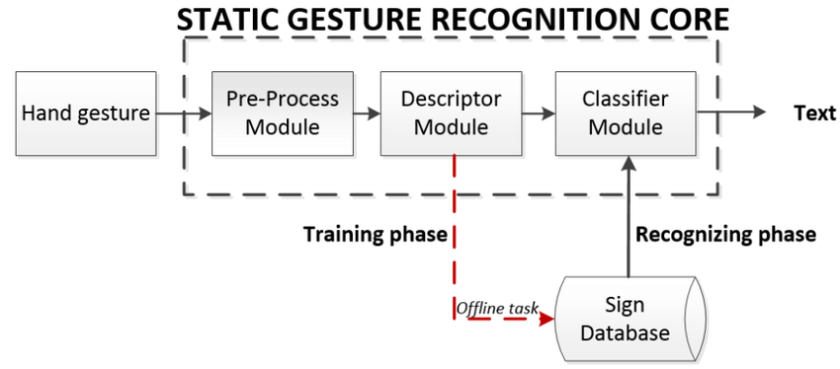 **fig1**

**1.Input process:**

1.This denotes the source of the input data, which could be a webcam or other type of camera that is recording a live video feed. The user's hand movements are captured in the video stream and are used as input by the system

**2. Pre-process module**

1. Colour normalization: The goal of colour normalization is to standardize the colour distribution of the input video frames such that they are consistent and homogeneous under various lighting and camera setups, To modify the colour balance and improve the contrast of the video frames, methods including histogram equalization, colour space transformations (e.g., RGB to HSV), and colour balancing algorithms may be used.

2. Background subtraction: Purpose: To isolate the regions of interest for additional examination, background subtraction is utilized to separate the user's hands from the background in the video frames.

3. Noise-reduction: The purpose of noise reduction techniques is to reduce undesired artifacts and disturbances in the video frames, hence enhancing the precision and dependability of the hand motions that are extracted.

4. Resizing: The purpose of resizing and cropping is to standardize the size and aspect ratio of the video frames to make processing and analysis more efficient.

**3. Descriptor module**

1. Feature Extraction: From the pre-processed hand gesture photos, the descriptor module extracts descriptive features that capture significant visual patterns, forms, and textures that distinguish various sign language symbols.

2. Normalization and Scaling: To guarantee consistency and comparability across various samples and datasets, the descriptor module may carry out normalization and scaling of the extracted features.

**4. Classifier module**

1. Using labelled training data—each example consisting of hand gesture photos and the associated sign language labels—the classifier module trains machine learning models. The models optimize their parameters to reduce classification errors as they learn to identify patterns and correlations between the retrieved data and the sign language signals.

2. The performance evaluation directs the selection of the best classifier for deployment by pointing out potential overfitting, underfitting, or generalization problems.

**Working**

**Data Collection:**

The project began with the initial step of data collection , which involved the use of cv2 to access the camera after accessing the camera the alphabet’s sign were made to create the dataset, accompanied by corresponding labels.

The datasets contained approximately 400 images of each sign and labels were also given to each dataset.

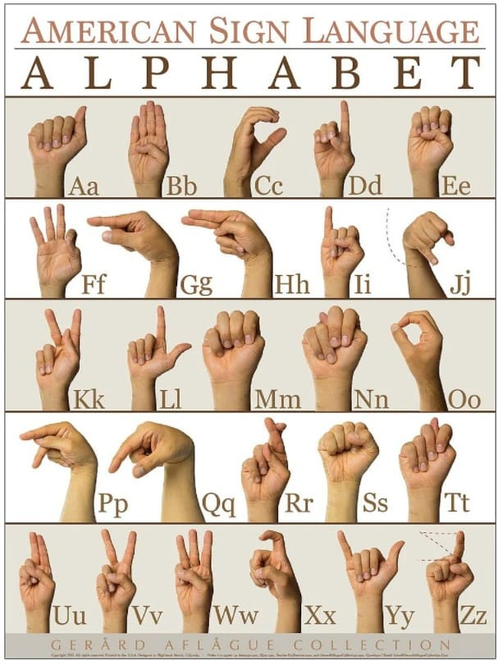

Fig 2 – Alphabets in Sign Language

**Data Preprocessing:**

Data preprocessing plays a critical role in ensuring the quality, reliability, and effectiveness of machine learning models by preparing the data in a suitable format for analysis and training. It helps mitigate potential issues and biases in the data while improving the performance and interpretability of the resulting models.

The dataset was preprocessed once it was loaded to make sure it was suitable for training models and of a high quality. To get the data ready for the next steps, this included resolving missing values, eliminating duplicates, converting labels to numerical representation, and carrying out additional data cleaning operations.

**Model Training:**

In machine learning and deep learning workflows, model training is a crucial stage where a model learns patterns and relationships to make judgements or predictions.

Once the processing was done, the data was uploaded to teachable machine for the training of model. Teachable machine used keras model for data training.

After the training process was completed and the model was ready to use it download and used in the project.

**Results**

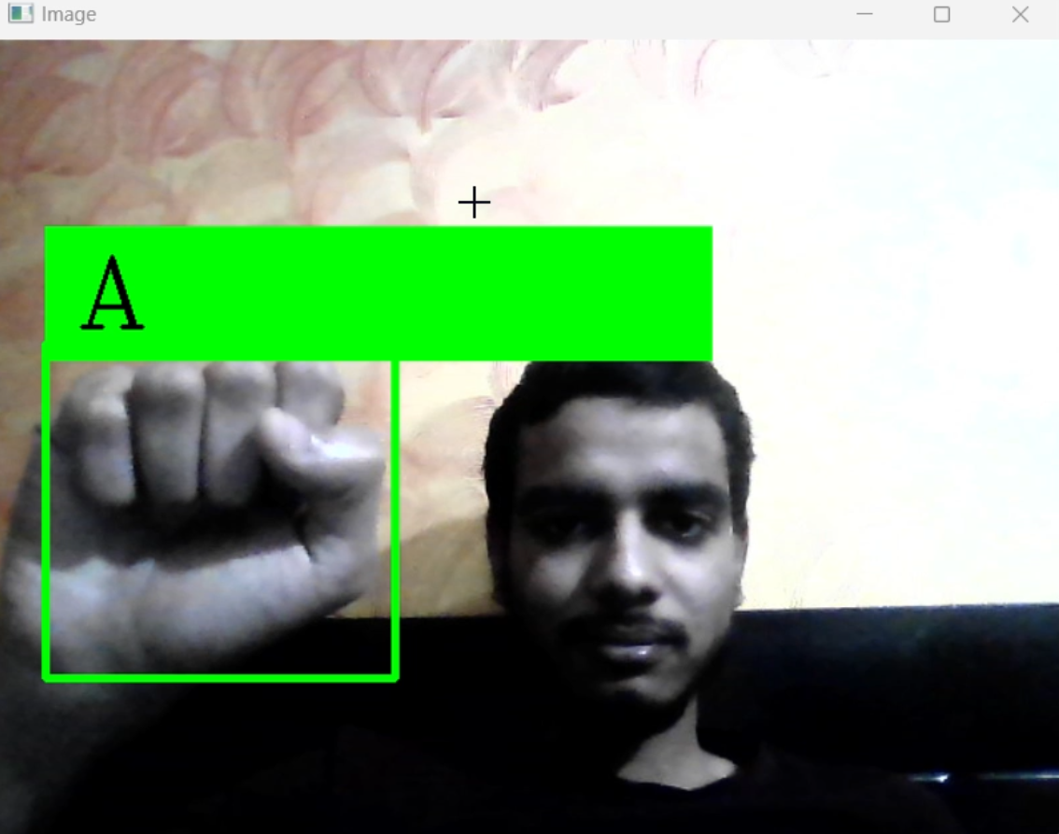

Fig 3 – A in Sign

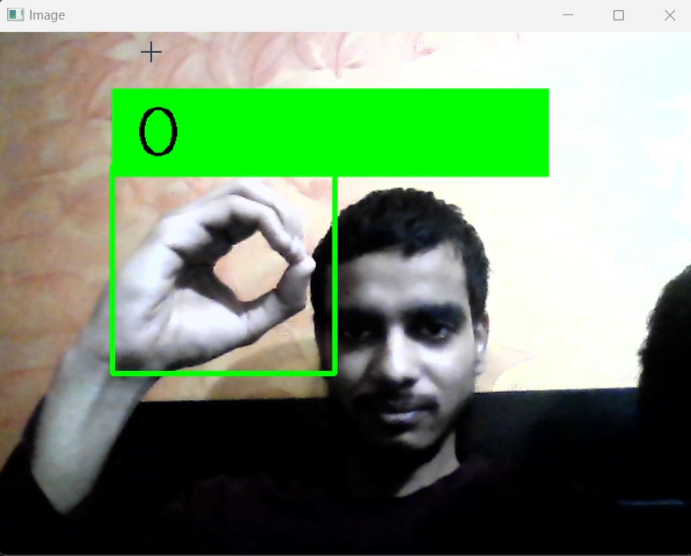

Fig 4 – O in Sign

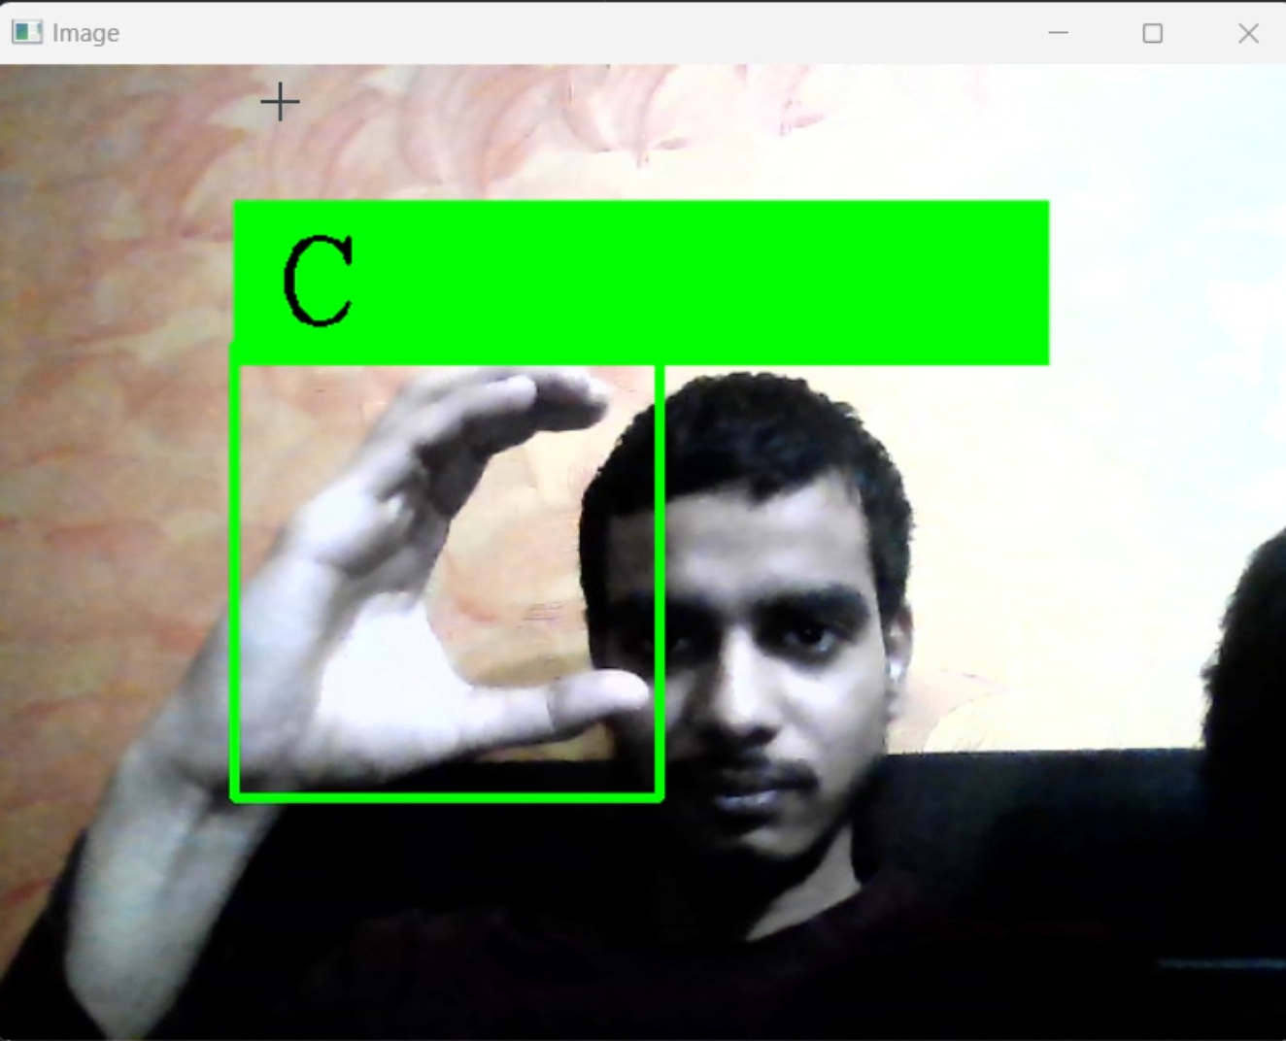

Fig 5 – C in Sign

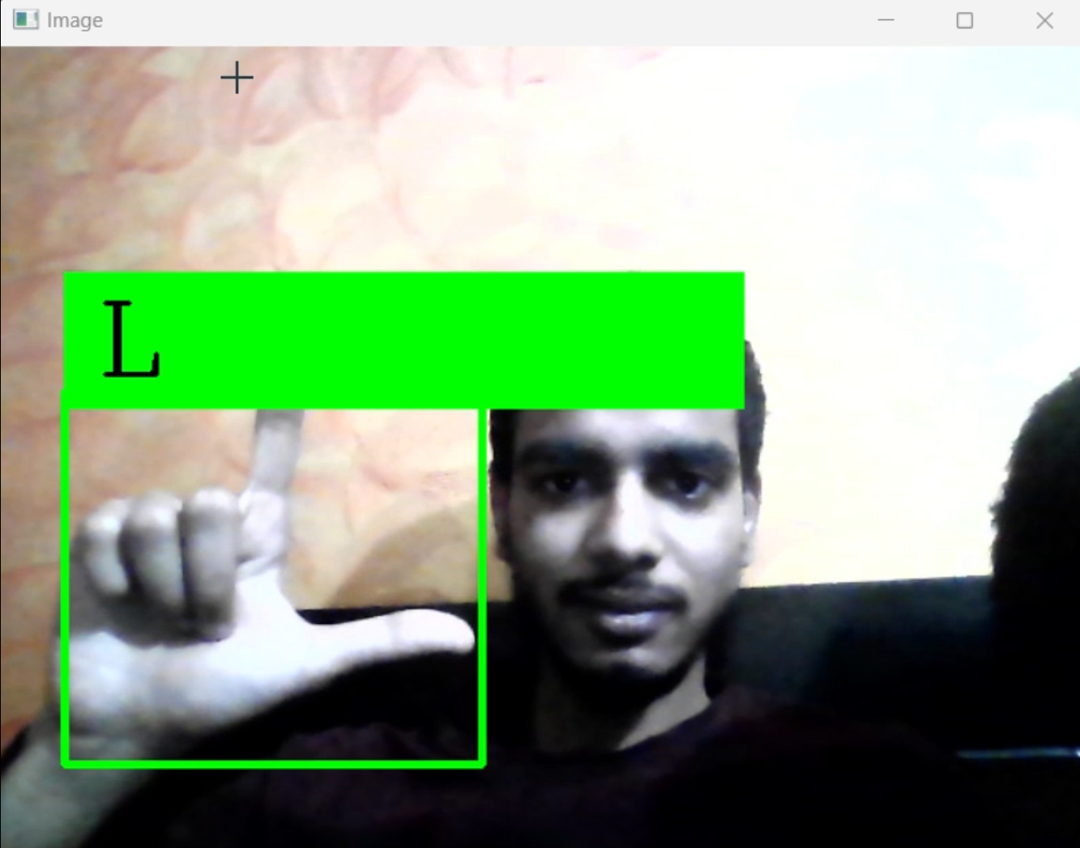

Fig 6 – L in Sign

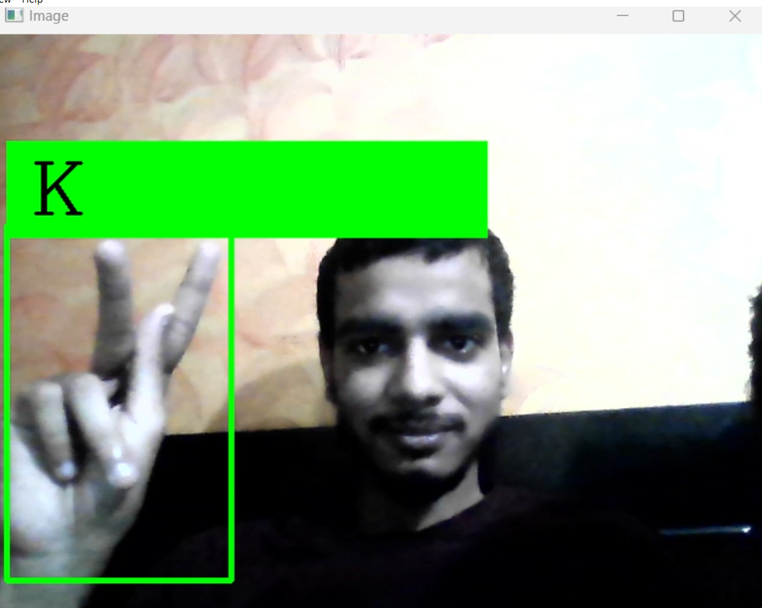

Fig 7 – K in Sign

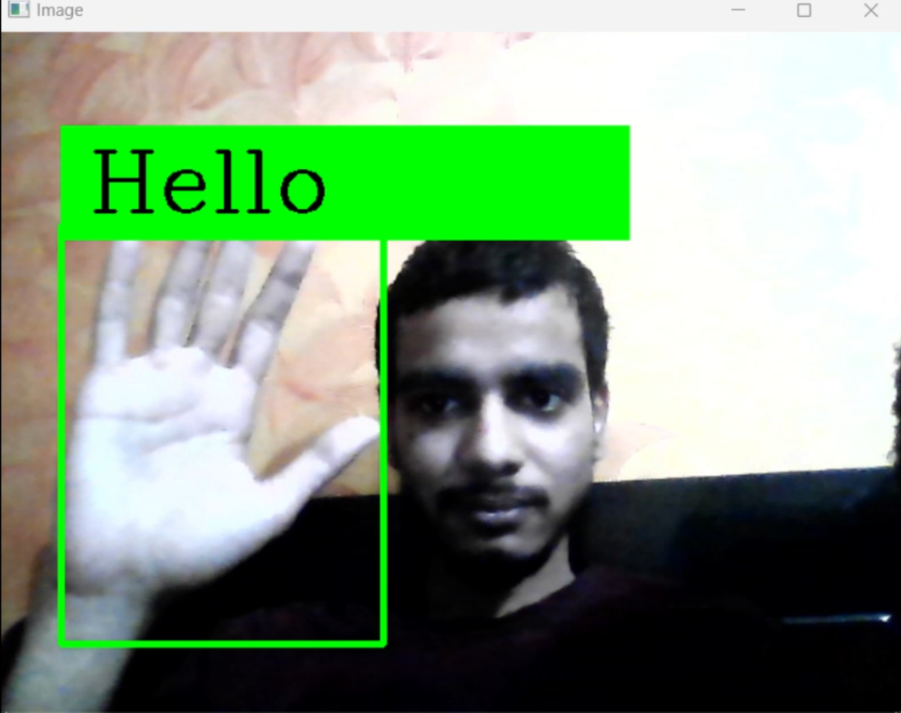

Fig 8 – Hello in Sign

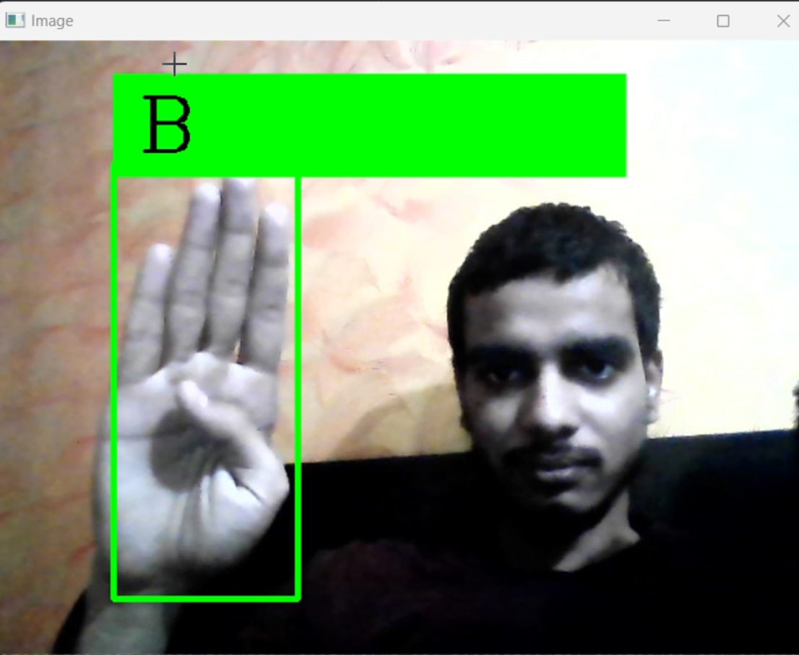

Fig 9 – B in Sign

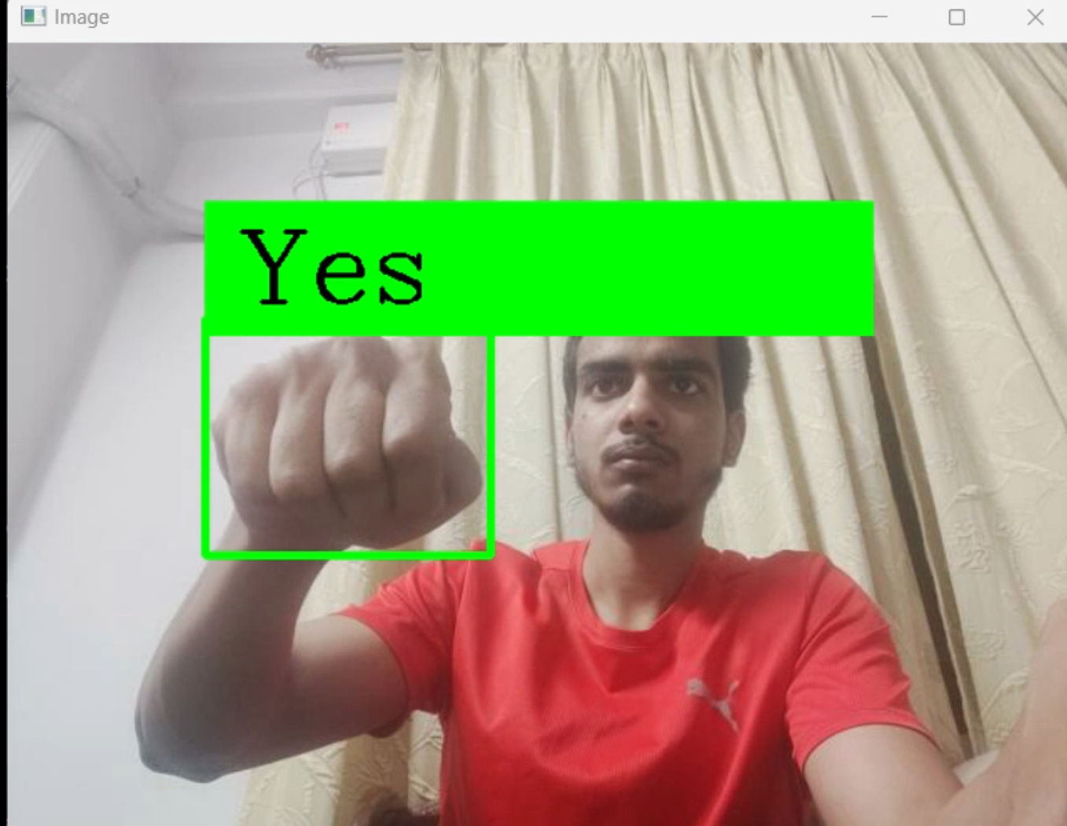

Fig 10 – Yes in Sign

**Future Scope**

With the potential to significantly improve communication between sign language users and spoken language speakers, the Real-time Sign Language Detection and Translation System is a significant leap in assistive technologies. Even while the existing system is quite functional, there are great opportunities to expand its scope and make future modifications to further increase accessibility, usability, and performance. Here, we examine the possible directions for further improvement and development.

**Expansion of Sign Language Vocabulary**

Adding more sign language words to the system's lexicon is a promising avenue for future development. A wider variety of sign language gestures and symbols can be incorporated into the system to support more in-depth and complex user interactions as well as a variety of communication demands. In order to ensure the system's relevance and inclusivity, user groups and sign language specialists can collaborate to inform the addition of new signs and gestures.

**Support for numerous Sign Language Dialects**

Future versions of the system may include support for numerous sign language dialects or variations in order to better serve a variety of user communities. The system's ability to identify and comprehend distinct regional or cultural variations of sign language enables it to accommodate the diverse linguistic preferences and communication styles of users from different backgrounds. Flexible models that have been trained on a variety of datasets can improve the system's adaptability and accessibility to various language communities.

**Enhanced Environmental Adaptation**

Upcoming improvements may concentrate on strengthening the system's capacity to adjust to changing user contexts and environmental circumstances. Robust hand gesture identification and tracking in a variety of lighting situations, backdrop surroundings, and user positions can be made possible using sophisticated computer vision algorithms and sensor technology. In real-world situations, adaptive algorithms that dynamically adapt to changes in the environment can improve the system's responsiveness and dependability.

**Personalization and User Customization**

The incorporation of tools for personalization and user customisation has the potential to improve system usability and user satisfaction. Users can adjust the behaviour and output of the system to suit their own requirements and tastes thanks to customizable settings, preferences, and user profiles. Users may tailor their communication experience and maximize efficiency with features like customizable dictionaries, adaptive feedback systems, and gesture recognition training.

**Sustained Research and Collaboration**

To propel innovation and tackle new issues in assistive communication technology, it is imperative to sustain research and collaborate with interdisciplinary teams comprising computer scientists, linguists, psychologists, and end users. Through establishing collaborations with educational establishments, research centers, and business partners, the system can gain access to the most recent developments in machine learning, HCI, and accessible architecture.

In conclusion, the Real-time Sign Language Detection and Translation System has a wide and bright future ahead of it in terms of improvements and breadth. Through adoption of a user-centred design methodology, utilization of state-of-the-art technologies, and promotion of cooperation and creativity, the system can adapt to users' changing requirements and enhance inclusivity, accessibility, and self-determination for people with varying language proficiency.

**Limitations**

Although the Real-time Sign Language Detection and Translation System is a great tool for improving communication between people who use sign language and people who use spoken language, there are some limitations that should be recognized and addressed as they may affect the system's functionality, performance, and usefulness in practical situations. Comprehending these constraints is imperative in order to steer subsequent research endeavours and guarantee the system's ongoing enhancement and adjustment to a variety of customer requirements. Here, we go over a few of the system's main drawbacks.

**Vocabulary and Gesture Variation**

Identifying a wide variety of sign language symbols and gestures is one of the system's main problems. The method might work well for signs that are often used, but it might have trouble with motions that are less common or context specific. The problem is further compounded by variations in hand form, movement speed, and orientation, which may result in misclassification or wrong interpretation of gestures.

**Restricted Sign Language Dialects**

The system's emphasis on identifying a particular sign language dialect or variation is another drawback. Regional and cultural differences can be seen in sign languages, which have unique vocabularies, grammatical rules, and gestural traditions. A wider audience may not be able to utilize the system due to insufficient support for individuals communicating through various sign language dialects.

**Environmental Factors**

Things like backdrop clutter, occlusions, and illumination might have a negative impact on how well the system works. The system's capacity to recognize and track hand motions effectively may be hampered by poor lighting, strong shadows, or complicated backgrounds. This could lead to poor performance or inconsistent interpretation of sign language expressions.

**Hardware Dependencies**

The system's performance could be constrained by hardware features including memory capacity, processor speed, and camera resolution. Deteriorating hardware or cameras with lower resolutions might affect the system's capacity to handle video streams quickly and accurately, which can diminish accuracy and responsiveness.

**Training Data Bias**

The caliber and diversity of the training data used to train the system's machine learning models have a significant impact on how well they work. Biases in the training set, including underrepresentation of particular demographics or sign language symbols, could lead to incomplete or biased recognition results, which could exclude or marginalize particular user groups.

**Continuous Improvement and Adaptation**

Research, development, and user feedback must be prioritized in order to address these restrictions. Prolonged algorithmic improvement, training dataset extension, and user community involvement are critical to improving the system's accuracy, inclusivity, and usability over time.

In conclusion, the Real-time Sign Language Detection and Translation System promotes inclusive communication and has many advantages; but, in order to fully utilize it, its limitations must be acknowledged and minimized. We can increase accessibility, equity, and understanding for people with different language capacities and progress the field of assistive technologies by tackling these issues through cooperative efforts and multidisciplinary research.

**BIBLIOGRAPHY**

1. Lu, Y., & Yuan, Y. (2019). "Deep Learning for Sign Language Recognition and Translation: A Survey." IEEE Transactions on Human-Machine Systems.

2. Stoll, S., & Kennington, C. (2019). "A Survey of Sign Language Recognition Methods." IEEE Transactions on Human-Machine Systems.

9. Han, J., Jang, S., Joo, M., Han, B., & Park, S. (2019). "Sign language recognition using wearable motion sensors and deep learning algorithms: a systematic review." *International Journal of Distributed Sensor Networks*, 15(11), 1550147719888904.

10. Athitsos, V., & Sclaroff, S. (2008). "Estimating 3D hand pose from a cluttered image." *Computer Vision and Image Understanding*, 108(1-2), 52-73.

These papers cover various aspects of sign to speech conversion, including recognition, translation, animation, and the use of deep learning methods.